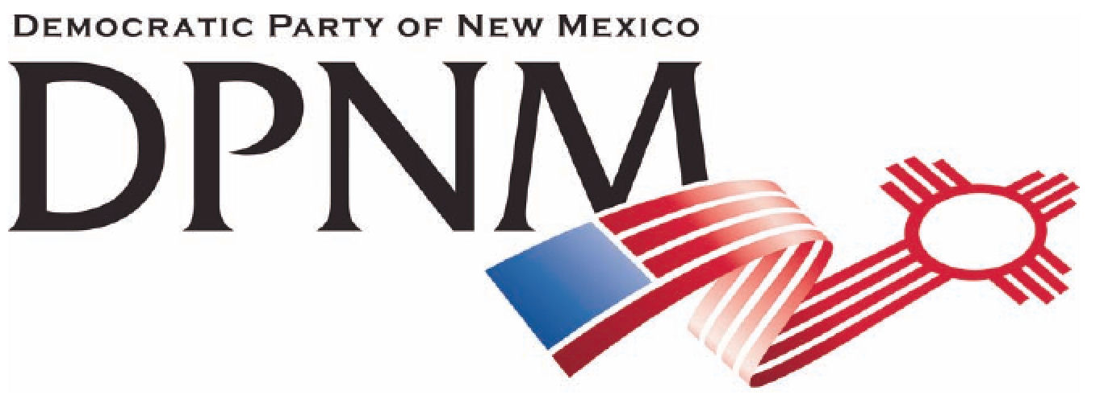
3200 Monte Vista NE
Albuquerque, NM 87106
www.nmdemocrats.net

Resolution Title: The Commons
Resolution author: first E-Mail address:
Address: City: Albuquerque County: Bernalillo State: NM ZIP:
Ward: Date submitted: Phone:

Whereas section
Whereas statements are the foundation for your resolution.
Whereas our country possesses a wealth of natural resources including the air, water, minerals, forests and land, that are part of our common heritage
And whereas our taxes have created an infrastructure of roads, schools, libraries, museums, zoos, jails and much more, that are part of our common resources,
and whereas the private sector has profited considerably from these natural and national resources,

Resolved section
Enter your resolution statement here. The resolution statement is used to tell what action should be taken.
Be it resolved that private enterprises must not pollute or otherwise damage that which is in the commons,
that profits from the commons be limited to the labor of extraction or processing, and not the resources themselves;
and that these public common entities such as schools not be privatized, nor be profit-making enterprises.

Addendum
If any facts or statistics are cited, references must be included.

