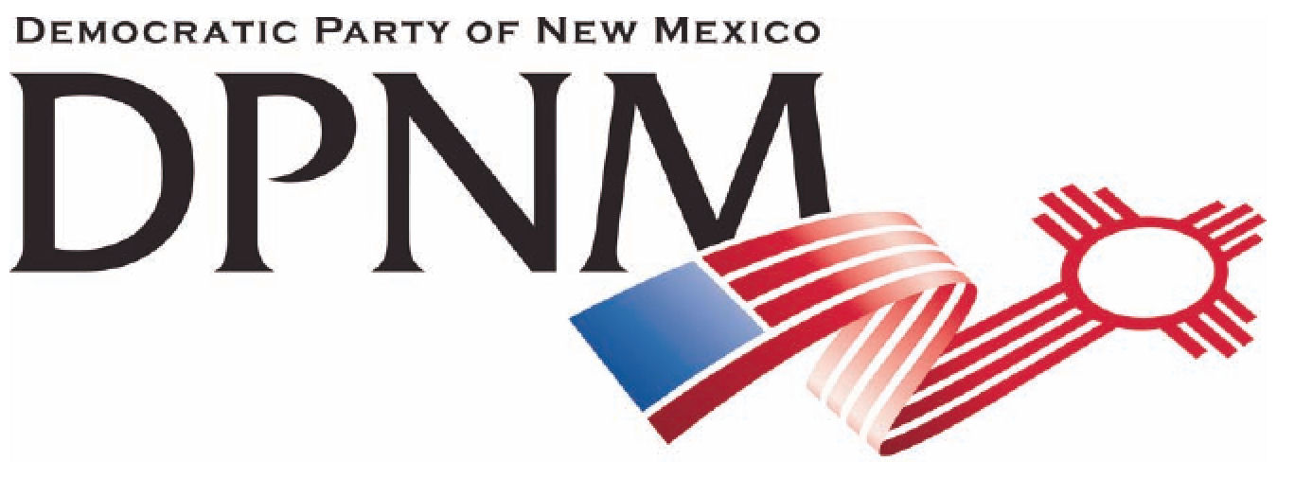
3200 Monte Vista NE
Albuquerque, NM 87106
www.nmdemocrats.net

Resolution Title: The 99%
Resolution author: first E-Mail address:
Address: City: Albuquerque County: Bernalillo State: NM ZIP:
Ward: Date submitted: Phone:

Whereas section
Whereas statements are the foundation for your resolution.
Whereas the gap between our wealthiest citizens and the 99% of our population has been widening steadily;
and whereas 50% of our population is now considered to live below the poverty line;
and whereas we are losing the middle class in our country because of this widening gap, causing increasing financial problems and a decrease in the power that the average citizen has to affect our government,

Resolved section
Enter your resolution statement here. The resolution statement is used to tell what action should be taken.
Be it resolved that the DPNM supports the Occupy Movement, and the 99% in order to allow all voices to be heard and all segments of our population to thrive.

Addendum
If any facts or statistics are cited, references must be included.

