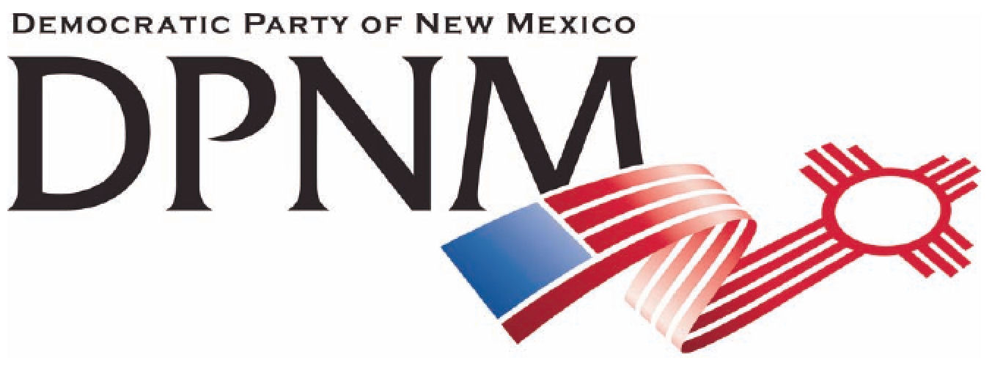
3200 Monte Vista NE
Albuquerque, NM 87106
www.nmdemocrats.net

Resolution Title: Tax Los Alamos National Lab
Resolution author: first E-Mail address:
Address: City: Albuquerque County: Bernalillo State: NM ZIP:
Ward: Date submitted: Phone:

Whereas section
Whereas statements are the foundation for your resolution.
Whereas Los Alamos National Labs is now owned and operated by private entities;
and whereas they are one of the most profitable agencies in New Mexico;
and whereas they have held onto their tax exempt status;
and whereas the revenues derived from their taxable earnings would contribute deeply to a reduction of our State debt;

Resolved section
Enter your resolution statement here. The resolution statement is used to tell what action should be taken.
Be it resolved that the DPNM supports taxing the income of LANL as it should any other corporation doing business in New Mexico.

Addendum
If any facts or statistics are cited, references must be included.

