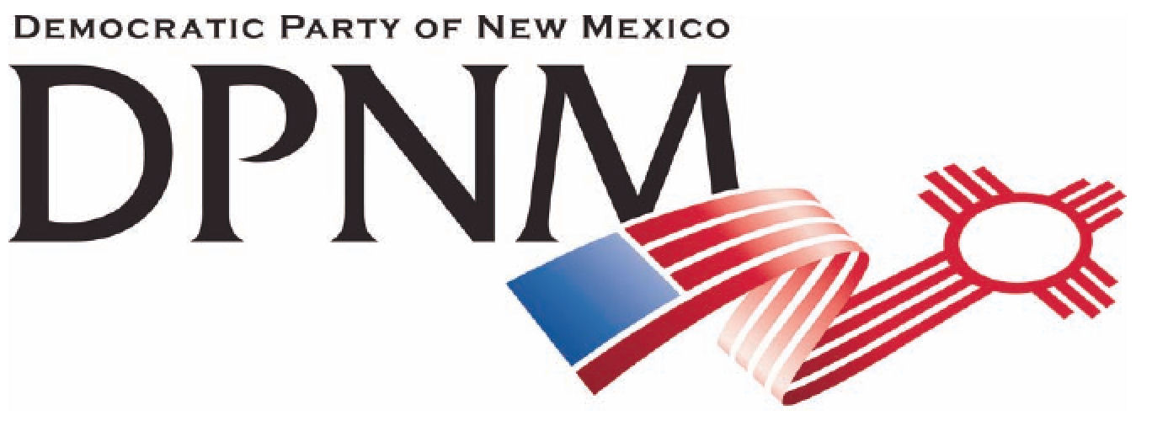
3200 Monte Vista NE
Albuquerque, NM 87106
www.nmdemocrats.net

Resolution Title: Repeal the NDAA
Resolution author: first E-Mail address:
Address: City: Albuquerque County: Bernalillo State: NM ZIP:
Ward: Date submitted: Phone:

Whereas section
Whereas statements are the foundation for your resolution.
Whereas the implementation of the December 31, 2011 National Defense Authorization Act further erodes all of the rights and freedoms granted us in the United States Bill of Rights,
and whereas the act was signed to codify unconstitutional practices already in practice,

Resolved section
Enter your resolution statement here. The resolution statement is used to tell what action should be taken.
Be it resolved that the DPNM support the repeal of the NDAA sections that are in violation of the civil rights granted us in the Bill of Rights.

Addendum
If any facts or statistics are cited, references must be included.

