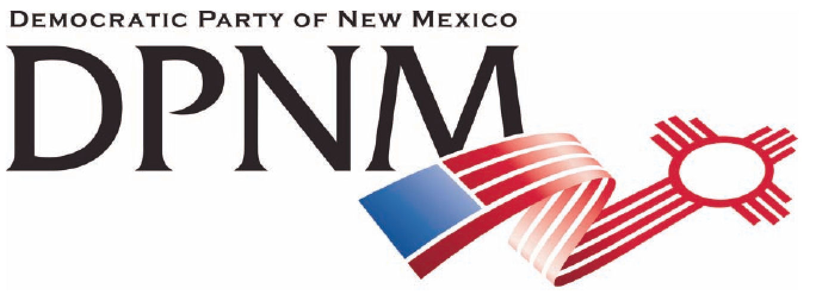
3200 Monte Vista NE
Albuquerque, NM 87106
www.nmdemocrats.net

Resolution Title: Prevailing Wages
Resolution author: first last E-Mail address:
Address: City: Albuquerque County: Bernalillo State: NM ZIP:
Ward: Date submitted: Phone:

Whereas section
Whereas statements are the foundation for your resolution.
Whereas unions are urging that all workers be paid prevailing wages, thereby protecting union and other
workers with decent wages.

Resolved section
Enter your resolution statement here. The resolution statement is used to tell what action should be taken.
Be it resolved that we apply this same standard for everything we import in the interest of supporting all
American workers.

Addendum
If any facts or statistics are cited, references must be included.

