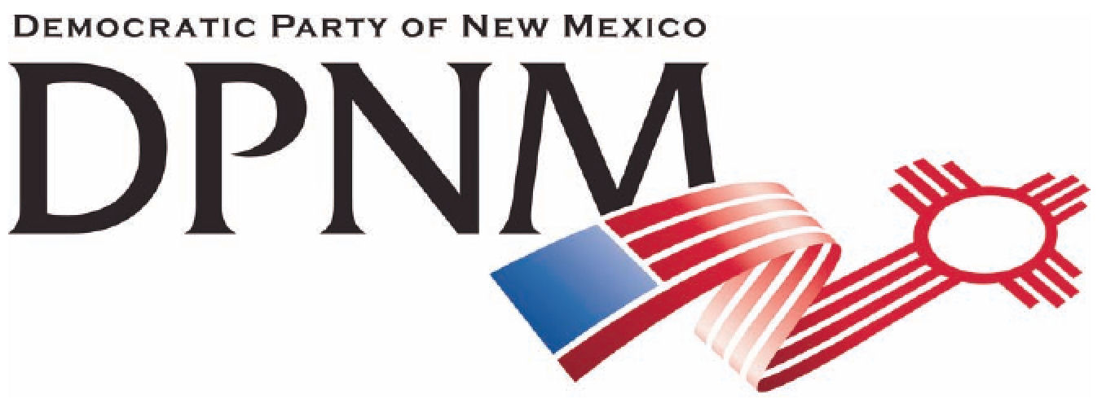
3200 Monte Vista NE
Albuquerque, NM 87106
www.nmdemocrats.net

Resolution Title: Funding Health Care
Resolution author: first E-Mail address:
Address: City: Albuquerque County: Bernalillo State: NM ZIP:
Ward: Date submitted: Phone:

Whereas section
Whereas statements are the foundation for your resolution.
Whereas the DPNM has on its platform that health care is a right;
and whereas insurance companies are prevent such a memorial from passing in the senate;
and whereas they argue it would cost taxpayers too much as there are no funds available;

Resolved section
Enter your resolution statement here. The resolution statement is used to tell what action should be taken.
Be it resolved that our state government take the sum total of all insurance premiums currently paid for by our population, and add to our tax structure an equal amount of taxes proportional to our income, so that our citizens can receive health care with no additional expense, and without adding to the monies the state currently spends.

Addendum
If any facts or statistics are cited, references must be included.

