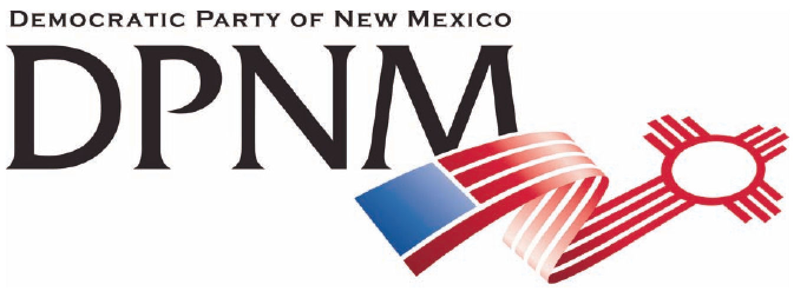
3200 Monte Vista NE
Albuquerque, NM 87106
www.nmdemocrats.net

Resolution Title: Fracking
Resolution author: first E-Mail address:
Address: City: Albuquerque County: Bernalillo State: NM ZIP:
Ward: Date submitted: Phone:

Whereas section
Whereas statements are the foundation for your resolution.
Whereas the practice of fracking has had unexpected consequences of causing earthquakes and environmental toxicity
and whereas fracking is increasing our carbon footprint,

Resolved section
Enter your resolution statement here. The resolution statement is used to tell what action should be taken.
Be it resolved that the practice of fracking be banned.

Addendum
If any facts or statistics are cited, references must be included.

