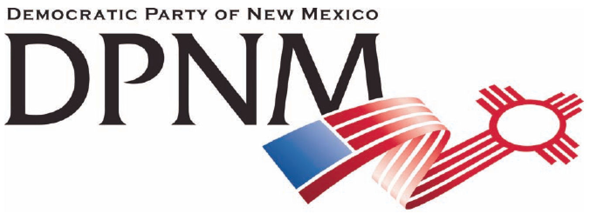
3200 Monte Vista NE
Albuquerque, NM 87106
www.nmdemocrats.net

Resolution Title: Financial Literacy
Resolution author: first E-Mail address:
Address: City: Albuquerque County: Bernalillo State: NM ZIP:
Ward: Date submitted: Phone:

Whereas section
Whereas statements are the foundation for your resolution.
Whereas a part of our economic crash since 2000 was caused by lack of education in financial management and its consequences;
and whereas our new economy provides fewer jobs, making the management of money even more difficult,

Resolved section
Enter your resolution statement here. The resolution statement is used to tell what action should be taken.
Be it resolved that financial literacy be a part of all New Mexico public school curriculums.

Addendum
If any facts or statistics are cited, references must be included.

