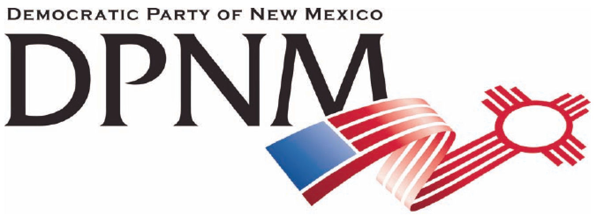
3200 Monte Vista NE
Albuquerque, NM 87106
www.nmdemocrats.net

Resolution Title: Access to Broadband
Resolution author: first E-Mail address:
Address: City: Albuquerque County: Bernalillo State: NM ZIP:
Ward: Date submitted: Phone:

Whereas section
Whereas statements are the foundation for your resolution.
Whereas we are in the midst of the information era;
and whereas access to information is critical to education as well as supporting the informed electorate necessary to maintain democracy;
and whereas the internet has become the “think hall” of democracy

Resolved section
Enter your resolution statement here. The resolution statement is used to tell what action should be taken.
Be it resolved that the State of New Mexico create the infrastructure required for universal access to broadband;
be it further resolved that all public schools teach digital literacy;
and be it further resolved that the internet remain open and uncensored to reflect the diversity of our cultures, values, experiences and perspectives.

Addendum
If any facts or statistics are cited, references must be included.

