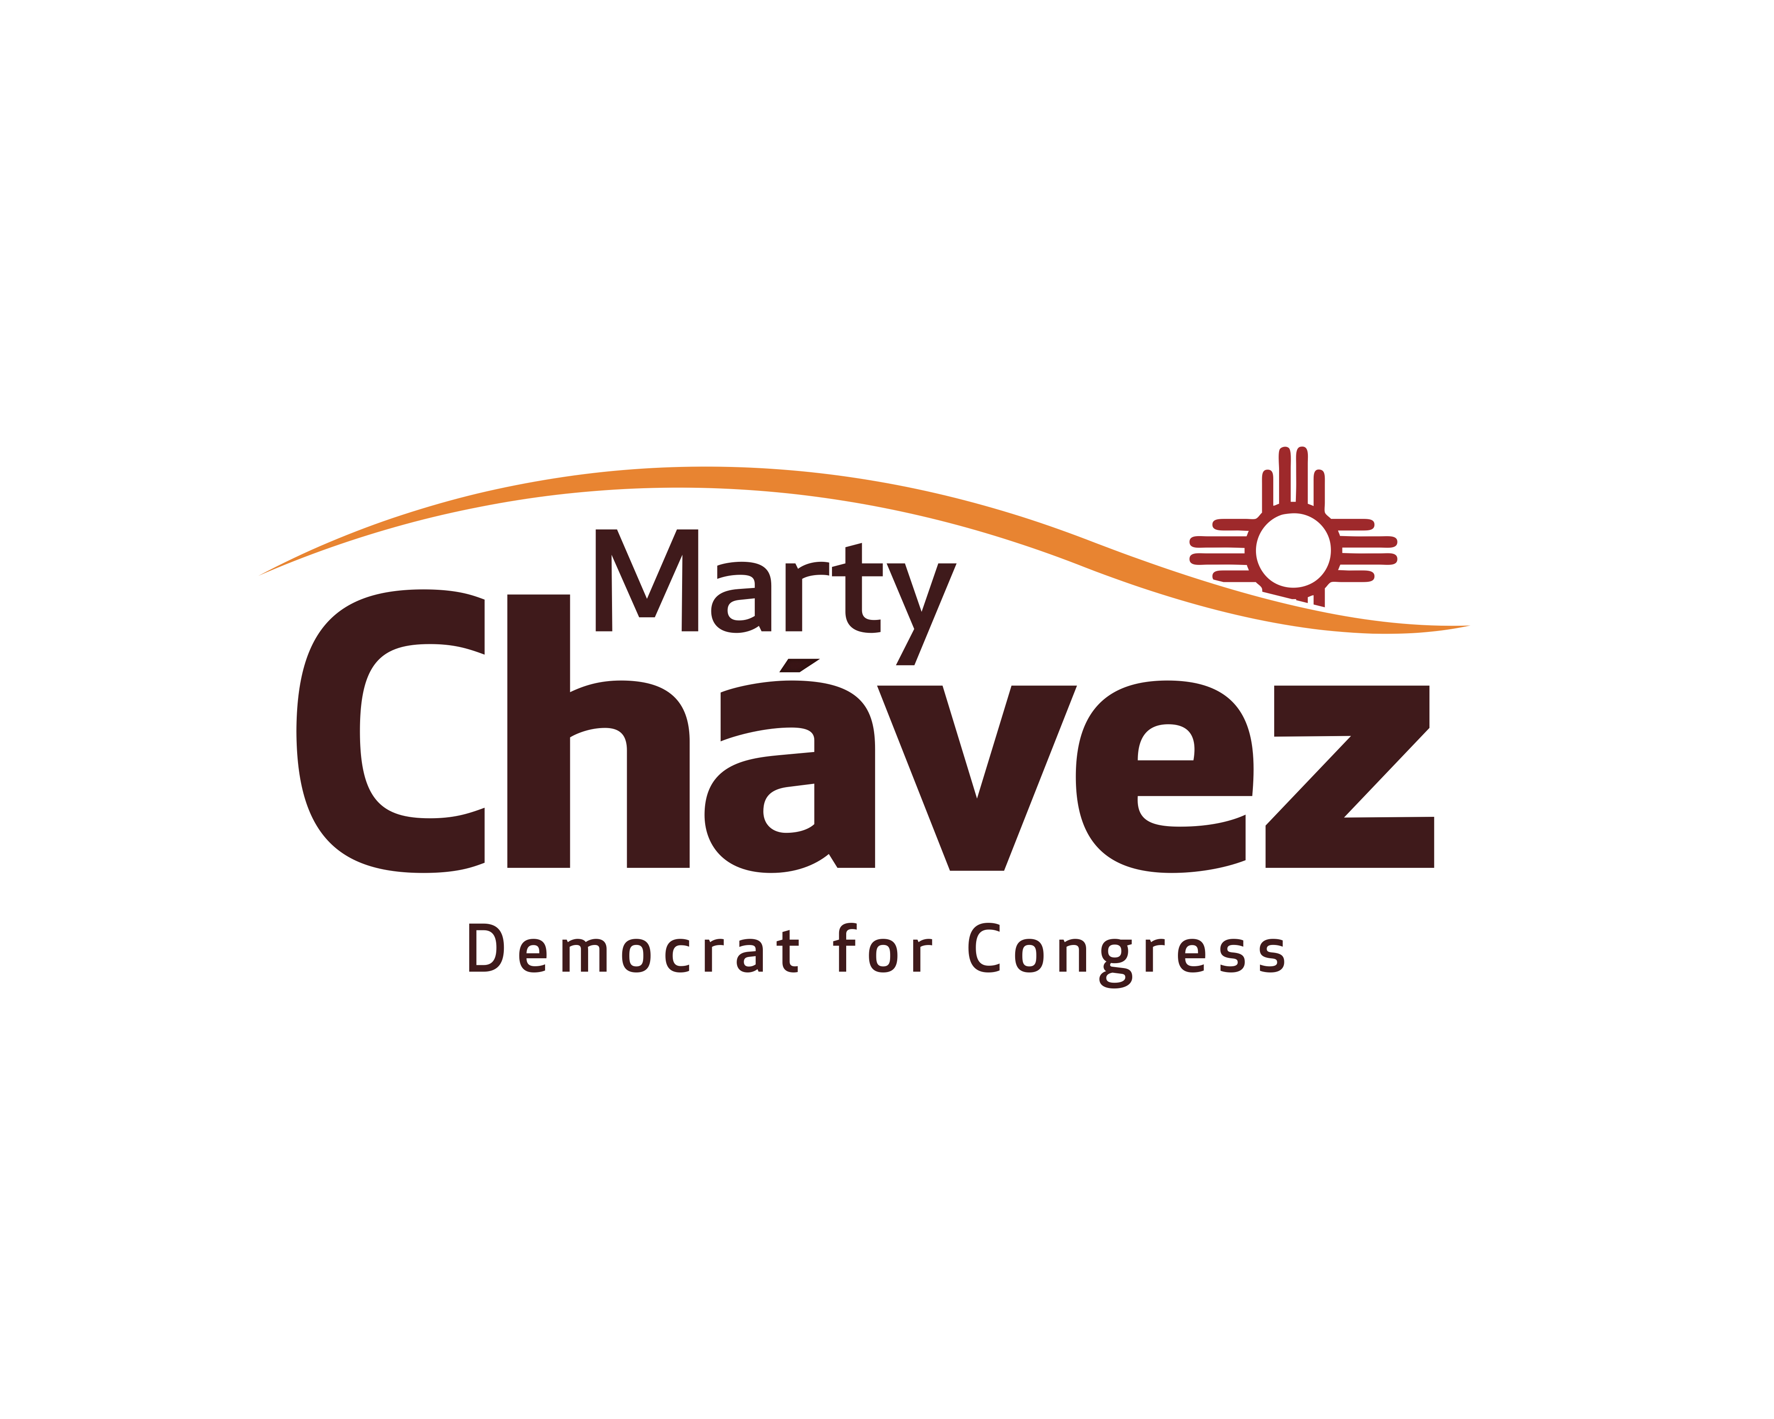
PLEASE JOIN
Robert McNeill
And Co-Hosts:
Arlene Chavez, Joanie Griffin and Tony Pedroncelli
(Host Committee still being formed)

For A FUNDRAISING RECEPTION
In support of
Marty Chavez
Candidate, N.M. 1st Congressional District

Sunday, September 25th
5:30 – 7:00 PM

Park Plaza Condos, Hospitality Room 1st Floor
1331 Park Avenue, SW
Albuquerque
(Park Plaza is a 15 Story building on 14th Street, SW, about a half a block south of West Central, and about half a block north of Park Ave)

Suggested Contribution:
$250 Host ~$100 Sponsor
$50 Friend ~ $25 Guest

RSVP to:
Janis Hartley (505) 412-2642 or janishartley@gmail.com
Contributions can be made payable and sent to:
“New Mexicans for Marty Chavez.”
PO Box 91208
Albuquerque, NM 87199
www.martychavez.com
Paid for by New Mexicans for Marty Chavez
Contributions can be made payable and sent to:
“New Mexicans for Marty Chavez.”
PO Box 91208
Albuquerque, NM 87199
www.martychavez.com
***September 25th ABQ Event***

Contributions to New Mexicans for Marty Chavez are limited to $5,000 per individual ($10,000 per couple) and federal multi-candidate PACs may contribute $5,000 per election ($10,000 maximum). A husband and wife may contribute a maximum of $10,000 by one check drawn from a joint account and signed by both individuals.

Contributions to New Mexicans for Marty Chavez are subject to the prohibitions and limitations of the Federal Election Campaign Act. Contributions from corporations, national banks, federal contractors, and foreign nationals who are not admitted for permanent residence in the United States are prohibited. All contributions must be made from personal funds and may not be reimbursed or paid by any other person. PAC checks will be accepted. Federal law requires us to use our best efforts to collect and report the name, mailing address, occupation, and name of employer for individuals whose contributions exceed $200 in an election cycle. If this is a contribution from a husband and wife by one check drawn from a joint account and signed by both individuals, please provide the requested information below for both individuals.

Name: ______________________________________________________________ Amount: ________________
Mailing Address: _____________________________________________________________________________
City: ______________________________________ State: _____________ Zip Code: ______________________ Occupation: ____________________________________ Employer: ____________________________________ Home Phone: __________________________________________ Work Phone: __________________________ Fax: __________________________________________________ Cell Phone: ____________________________
Email: _______________________________________________

If you prefer to pay by credit card, please complete the following:

Credit Card Type: _____ Visa _____ MasterCard _____American Express
Name on card: __________________________________________________________ Amount: _____________
Billing Address (if different): ___________________________________________________________________
Card Number: _________________________________________________________ Exp. Date: _____________

YOU MUST ALSO SIGN BELOW
• By signing below, I affirm that I am making this contribution with my own personal funds, and I am not using funds provided by any other person.
• By signing below, I am affirming that I am making this contribution on my own personal credit card and not with a corporate or business card or a credit card issued to anyone else (except for my spouse).

Contributor Signature (REQUIRED): ______________________________________________________________________ Contributions or gifts to New Mexicans for Marty Chavez are not tax deductible.

Paid for by New Mexicans for Marty Chavez

