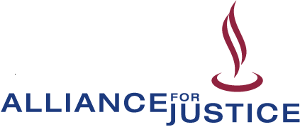

Presents
Worry-Free Advocacy:
Understanding the Rules of Nonprofit Advocacy and Election-Related Activity

During this one-day workshop for nonprofit managers, staff, and volunteers, our attorney-trainers will teach you the rules so that you can answer questions such as:
► What is lobbying?
► How much can our 501(c)(3) lobby?
► What are the state rules and regulations we need to be aware of?
► What types of election-related activity can our 501(c)(3) and 501(c)(4) engage in?

Co-sponsored by:  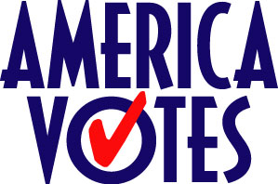  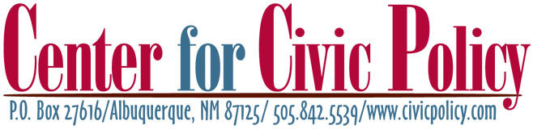 | August 29, 2007  9:00 a.m. to 4:00 p.m.  AFSCME  1202 Pennsylvania NE  Albuquerque, NM 87110  $40 before August 15th  $60 after August 15th  Registration fee includes all workshop materials and lunch.

For information, registration or other workshop dates, visit www.afj.org/worryfree.html
Questions? Contact Jasmeet Sidhu at (202) 822-6070 or Jasmeet@afj.org

11 Dupont Circle, N.W., 2nd Floor • Washington, D.C. 20036 • Phone: 202-822-6070 • Fax: 202-822-6068

