T A R G E T: I R A N
An eyewitness presentation by

David Barsamian
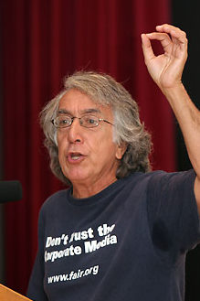
Alternative Radio's Director, David Barsamian is just back from a trip
to Iran. As the Bush Administration increases its threats toward Iran what
are the prospects for war. What do Iranians think and say about Washington actions?

Barsamian, who is Armenian, speaks some Farsi and is knowledgeable
about the politics and culture of Iran and the Middle East.
His forthcoming book is "Targeting Iran."
Listen to Alternative each Saturday at 6 pm on KUNM-FM, 89.9 MHz.

Friday, March 9, 7 pm
Smith-Brasher Hall
Central New Mexico Community College campus
(SW corner of Coal and University Blvd.)

Local info: StoptheWarMachine@comcast.net, 505-858-0882
Barsamian http://www.alternativeradio.org/, info@alternativeradio.org

