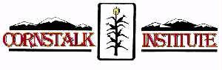
R A F F L E
Support award-winning youth programs at the ‘Stalk and win a chance
to drive away in Maybelline, a great-running 1959 Pontiac Catalina.
Won’t you look sweet!
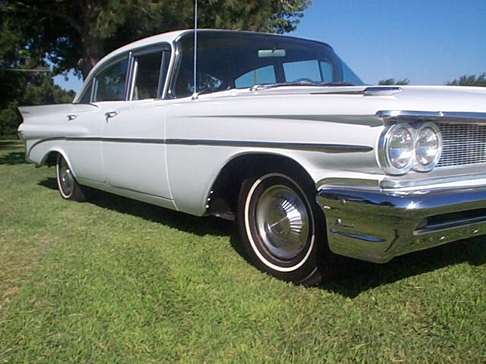
“…throw your suitcase in the back
done gassed up the Pontiac
blastin’ out to Johnny Cash, headin’ for
the highway baby… we ain’t ever comin’ back.”

All Proceeds Benefit Cornstalk Institute
Scholarship Programs

Certified, Guaranteed Satisfaction
Drawing held on June 16, 2007 at The Festival of the Great Unknowns,
all-day MusicFest benefiting the Cornstalk Institute. You don’t need to be present to win, but we hope you will!
More info about the music festival? Contact: cornstalkinstitute@yahoo.com
Food * Music * Drink & Friends*
name ___________________________________
address ________________________________
phone(s) _______________________________
e-mail _________________________________
_____Raffle tickets @ $25.00 each____OR the DEAL:Five tickets for $100____
Grand Total for the ‘Stalkers $_________

 please make your generous checks payable to Cornstalk Institute 
Raffle entries and checks to  Maybelline c/o Cornstalk Institute
 3011 Barcelona Road,SW  Albuquerque,NM 87105

