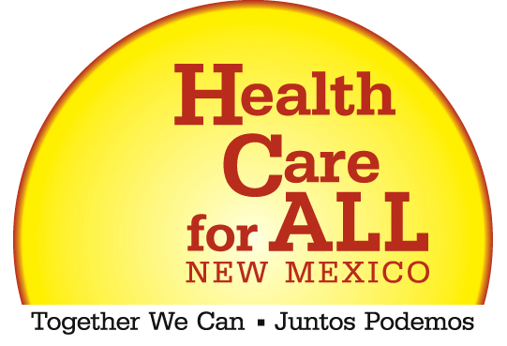

Health Care for All Campaign Supporters…
NOW IS THE TIME TO BE HEARD!

All organizations, businesses, faith groups, insured, uninsured, and underinsured persons, health care professionals and advocates are invited to speak up with their concerns and ideas regarding health care access and affordability at the:

HEALTH COVERAGE FOR ALL NEW MEXICANS COMMITTEE
PUBLIC INPUT MEETING

WEDNESDAY, SEPTEMBER 27TH
3PM – 7:30PM
(Public input begins at 5:15pm)
STATE CAPITOL, ROOM 317, Santa Fe

THIS IS AN EXTREMELY IMPORTANT OPPORTUNITY FOR PUBLIC INPUT concerning the rising cost of health care and the need for reform of the health care system in New Mexico.

The state sponsored Health Coverage for All New Mexicans Committee is charged with identifying various universal health care models to be compared by national experts with respect to projected costs in order to determine which model is best for New Mexicans. Committee Chairperson, Lt Governor Diane Denish announced this one-and-only meeting for public input.

Don’t miss this opportunity - Now is the time to have your voice heard. The Health Care for All Campaign is committed to:

- universal health care coverage for all persons living in New Mexico;
- models to be selected for this study should be real reform of the current system, not merely an expansion of the current system; and,
- models selected should address administrative and other cost savings for the system.

HOW TO EXPRESS YOUR CONCERNS TO POLICY MAKERS:

 Email Ruby Ann Esquibel at Rubyann.esquibel@state.nm.us and ask to be put on the list to speak at the public meeting on September 27, 2006;

 Call Ruby Ann Esquibel at 505-827-1345 and ask to be put on the list to speak at the meeting;

 Come and sign up to speak at the September 27, 2006 public meeting; or,

− Write your comments and email to Rubyann.esquibel@nm.state.us or mail to Ruby Ann Esquibel, Human Services Department, PO Box 2348, Santa Fe, NM 87504-2348, or fax to 505-827-3185.

For More Information, call the Health Care for All Campaign at 505-314-0656 or visit www.healthactionnm.org.

