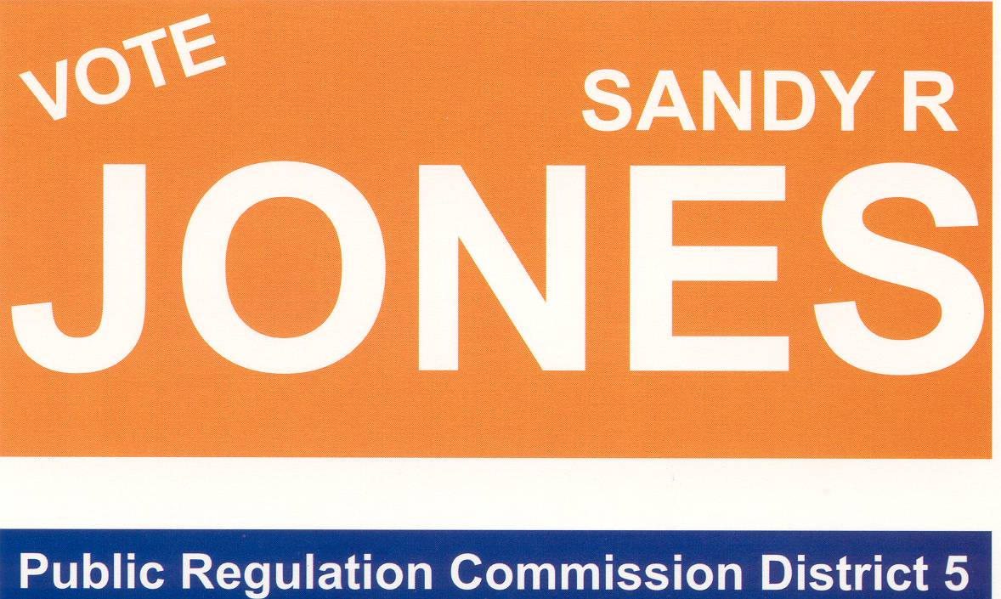

You are invited to a
BBQ
Thursday, November 2nd
at
Sandy Jones for PRC Headquarters
280 N. Date
T or C, NM
5:00 – 7:00 pm

Contributions accepted
but not required.
Bring your friends and join us for an
Old fashioned Political Rally and BBQ.

Paid for and printed by Sandy Jones for PRC, Ginni Jones Treasurer

