

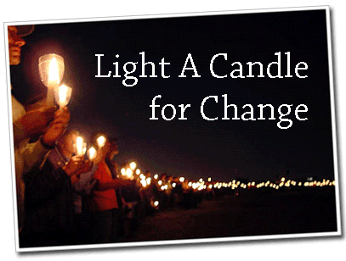

This Holiday Season, it’s time for Wal-Mart to reflect our moral values
- Adopt a zero tolerance policy on child labor
- Provide affordable health care to Wal-Mart workers and their families
- Pay hard working men and women a living wage
- Treat all workers – men and women – with respect and dignity

Join thousands of Americans this weekend at Candlelight Vigils all across the nation calling on Wal-Mart to change and become a responsible and moral company.

What: Albuquerque Candlelight Vigil for Change

Where: store #2008
2701 Carlisle Blvd NE
Albuquerque, NM 87110

When: Sunday, December 11, 3:00 p.m.

Why: Because America’s largest corporation should reflect America’s values

To RSVP: Call 242-7411 or email nmacorn@acorn.org

WakeUpWalMart.com

