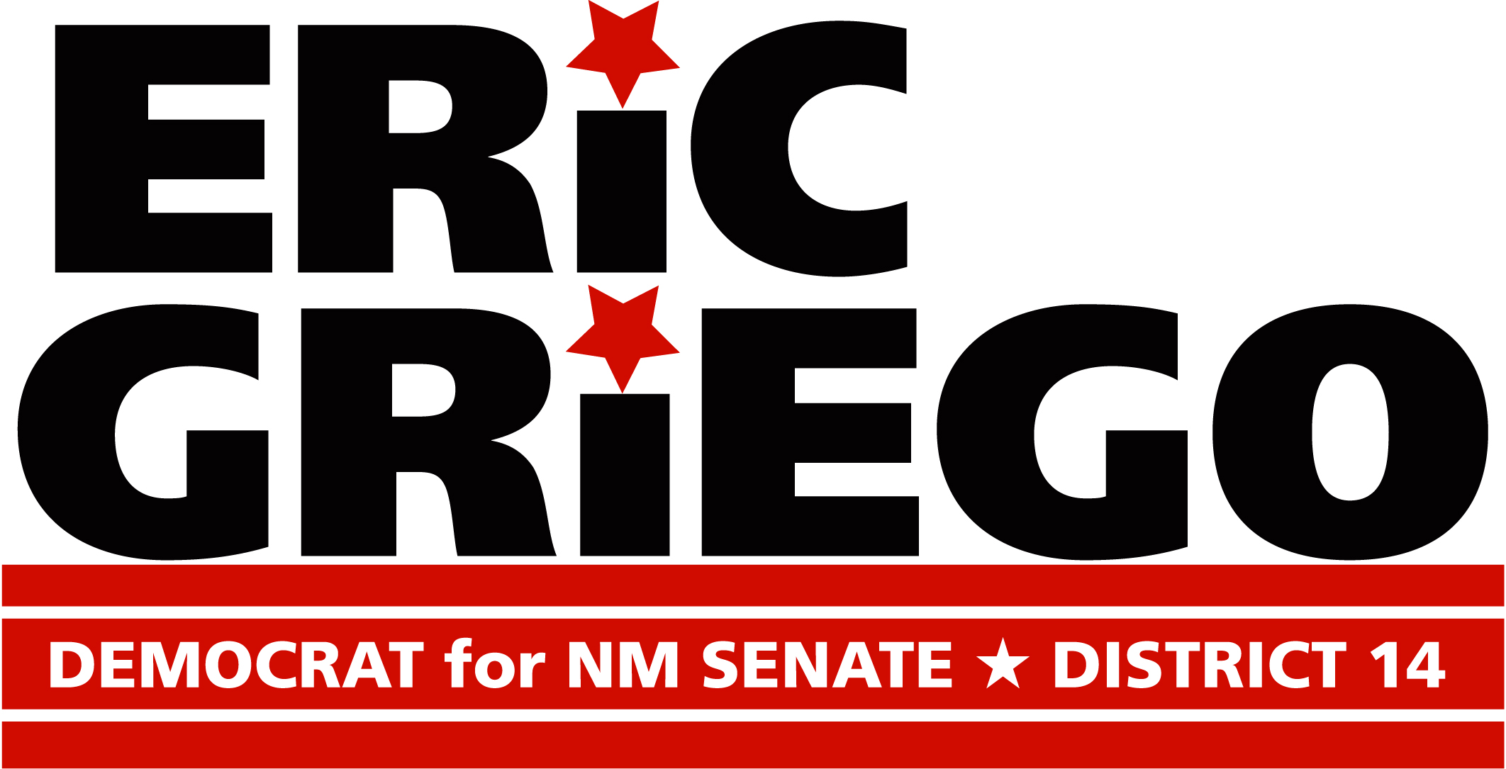
Healthy Communities Fundraiser
For Eric Griego for State Senate
Dear Friends:
You are invited to a party with a purpose! Meet progressive Democratic candidate for State Senate District 14, Eric Griego, at an evening gathering with fellow advocates who support:
- Smart growth and sustainable development
- Conservation, including better protection for the Rio Grande
- Bike-, walk-, and dog-park- friendly communities for healthy citizens and their companion animals
- Safe, clean, and live-exit animal shelters
Date: Wednesday, April 30th
Time: 5:30 – 7:30 PM
Location: 723-B Silver Ave. SW 87102
(Basement of Downtown Flying Star)
Suggested Contribution: $25.00
RSVP now! http://actblue.com/page/egriegohealthy/recipient/86467
Host Committee:
Infill Solutions: Innovative Urban Design and Development, Christopher Calott, Jay Rembe, Brian Cassutt, Leanne Leith, Javier Benavidez, Hildegard Adams, Claude Morelli, Viki Elkey, City Councilor Debbie O’Malley, Karen Borch, Gabriel K. Nims, Dely Alcantara, City Councilor Isaac Benton, Mary Ellen Broderick, Barbara Wold …
More to come!
Endorsed by:
- Conservation Voters New Mexico
- Albuquerque DFA-Democracy for New Mexico

Paid for by the Committee to Elect Eric Griego, Dely Alcantara, Treasurer. Printed in house.

