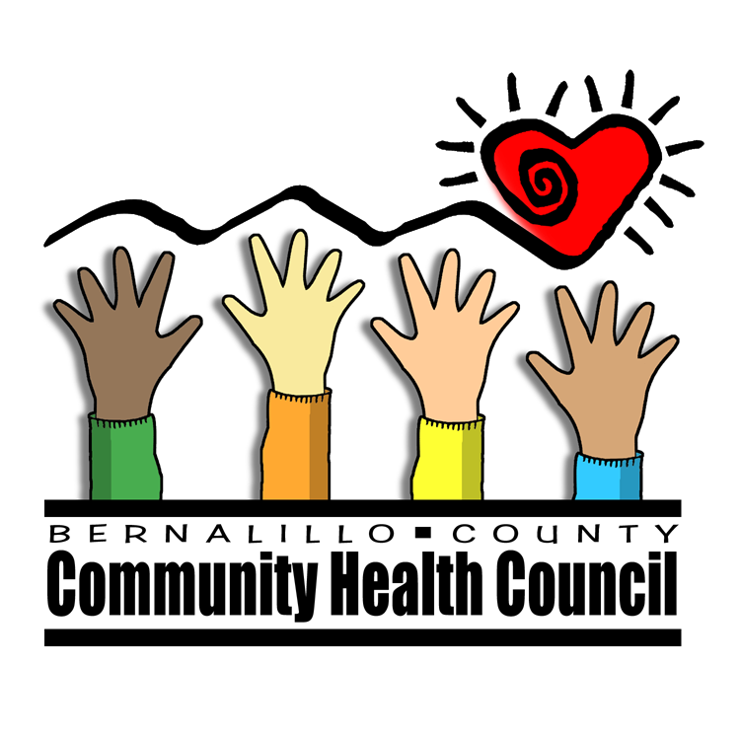
Community Forum

“Achieving Health Care for All”

Presentation and Discussion about the

New Mexico Health Care Reform Study

Join members of the community to discuss the results of a state-sponsored study comparing various models of universal health care, the work of the Governor and Legislative Health Coverage for New Mexicans Committee, and achieving health care for all people living in New Mexico.

Date: Tuesday, July 17th, 2007
Time: 6:00-8:00 pm
Location: 3701 Carlisle NE, Southwest corner of Comanche and Carlisle in NE Albuquerque

Light refreshments
Spanish interpretation provided

For More Information Call Leigh Mason, 975-9667
Local Cosponsors:

Bernalillo County Community Health Council
Native American Health Care Council of New Mexico
St. Joseph’s Community Health

Statewide Sponsors:
Health Care for All Campaign
New Mexico Voices for Children
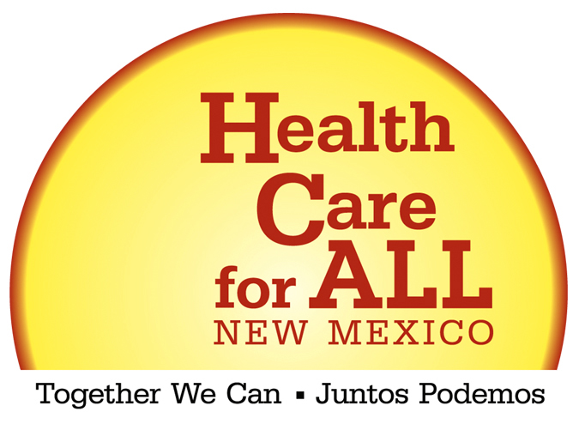
League of Women Voters NM
AARP
NM Conference of Churches
NM Human Needs Coordinating Council
NM Coalition for the Homeless
Health Action NM

