“It’s better than Cats!”

“I can’t wait to see the Chavettes!”

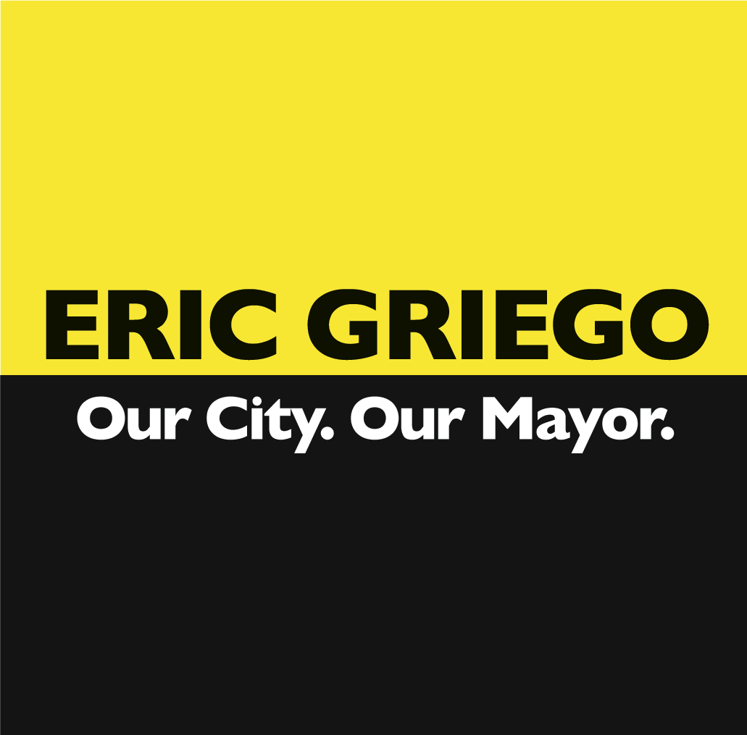

Please join us for a Final Fundraiser with Mayoral Candidate

Eric Griego

An Evening of Comedy

The Golden West Saloon
620 Central Ave. SW

7 p.m., Monday, September 26

Suggested Donation: $20

For Tickets call the Golden West Saloon at 242-2353 or call Molly at 224-9042
www.ericgriego.com. Printed In House. Sponsored by Friends of Eric Griego.

