
Democratic Party of New Mexico
April 9, 2005

Dear State Central Committee Members and Party Officials:

The Democratic Party of New Mexico will hold a State Central Committee Meeting on Saturday, April 23, 2005 at 10:00 a.m. (registration at 9:00 AM) at the Macey Center on the campus of New Mexico Tech, in Socorro. Meeting will end promptly at 1:00 PM for those observing Passover.

The primary purpose of this meeting is to hear from our Democratic elected leaders, elect new State officers, and adopt resolutions. In addition to our normal Party business, we have added several items to our weekend schedule and we hope that you can join us for those as well.
- To kick off this great weekend, Governor Bill Richardson will be our special guest at a cocktail reception (cash bar) for all at the Macey Center in the Galena Room. Tickets will cost $25.00 for state central committee members and $30.00 for non-members.
- On Friday, April 22 from 1:00PM – 5:00 PM there will be a training designed for County Chairs and Vice-Chairs. We will discuss the best practices and lessons learned from the 2004 election and the features and tools available from the state party to assist county parties. This training is exclusive to County Chairs, Vice-Chairs and the Executive Committee of the Democratic Party.
- Join us for an Eat-Up! Saturday afternoon. Enjoy an alfresco luncheon with other state central delegates and elected officials. Lunch will cost $7.50 per person.
- Afternoon sessions have been arranged to provide time for Democratic Women, Veterans, Progressives, Native Americans and Young Democrats to meet informally, as well as an opportunity for democrats to discuss ways to engage the media, promote the democratic message and effective strategies for grassroots organizing.*
Enclosed, you will find an invitation and response form for the Friday evening reception, a Saturday afternoon session registration form, a list of area hotels and special rates for your use in making reservations, and a map directing you to the Macey Center. Please return your reservation for the reception and your Saturday afternoon session registration to the headquarters, 1301 San Pedro NE, Albuquerque, NM 87110 or fax them to 505-830-3645, no later than Wednesday, April 20, 2005.

Please mark your calendar and plan to attend the fundraiser and the State Central Committee Meeting. If you have any questions, please call the headquarters at 505-830-3650 or visit our website at www.nmdemocrats.org.

I look forward to visiting with all of you.

Sincerely,
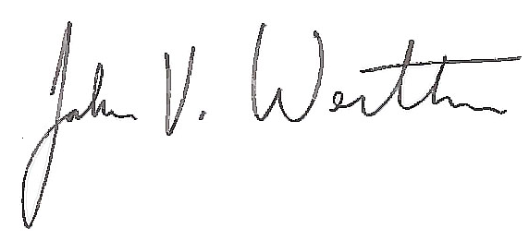
John V. Wertheim
Chair
*All trainings will be offered again at the Regional Meetings.

